ADVANCE INFORMATION SHEET

For interviews and editorial opportunities, please contact Amanda Saint at Retreat West Books on amandasaint@retreatwest.co.uk
https://retreatwestbooks.com

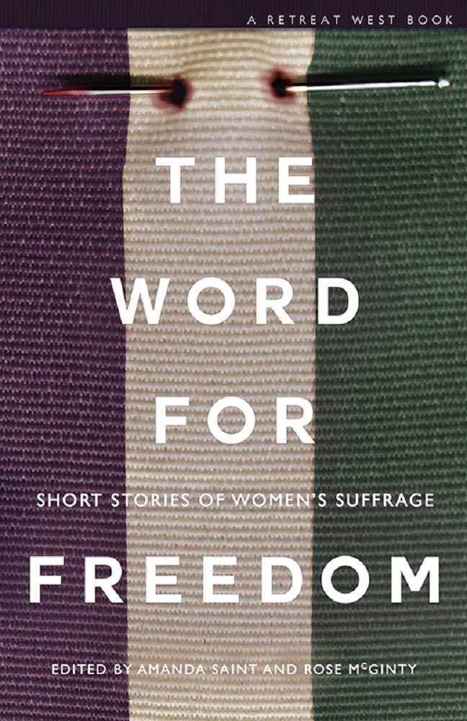

Category: Short Story Anthology
Publisher: Retreat West Books

ISBN:
eBook – 978-1-9164483-5-3
Paperback – 978-1-9164483-4-6

Format: eBook – 01/11/2018
Paperback – 01/11/2018

Available on Amazon, iBooks, Kobo and through IngramSpark and Gardners

Price: £8.99 (paperback) £3.99 (ebook)

Release Date: 01/11/2018 (eBook) & 01/11/2018 (paperback)

Book title: The Word For Freedom
By: Various

INSERT AUTHOR IMAGE HERE
The Word For Freedom
by Various

The Word For Freedom is a charity collection of short stories and flash fictions celebrating 100 years of women’s suffrage in the UK. It is raising money for Hestia, a charity supporting people trapped in modern slavery or domestic violence.

Featuring stories from award-winning and bestselling authors such as Angela Readman, Anna Mazzola, Angela Clarke and Isabel Costello, it also showcases work from emerging writers from around the world, all of whom have been inspired by the suffragettes and whose stories, whether set in 1918, the current day or the future, focus on the same freedoms that those women fought for so courageously.
A clerk of works at the Palace of Westminster encounters Emily Davison in a broom cupboard; a mermaid dares to tread on land to please the man she loves; a school girl friendship makes the suffragette protests relevant to the modern day; a mother leaves her child for a tree; an online troll has to face his target; and a woman caught in modern day slavery discovers a chance for freedom in a newspaper cutting.
These stories and many more come together in a collection that doesn’t shy away from the reality of a woman’s world, which has injustices and inequalities alongside opportunities and hard-won freedoms, but always finds strength, bravery and hope.

The suffragette spirit lives on in this moving, inspirational and still-relevant collection. Everyone should read it.
Erin Kelly – author of He Said, She Said

Thought-provoking stories of strength and wisdom - a wonderful celebration of women's voices.
Isabel Ashdown – author of Beautiful Liars

